**Mobile Testing – Wattpad Beta**

|  |  |
| --- | --- |
| **Bug ID:** | 1 |
| **Bug Summary** | UI issues with button size and text |
| **Environment/URL** | Wattpad Beta (Installed from Android market) |
| **Phone Model** | Samsung Galaxy S8 |
| **Operation System:** | Android 9 |
| **Version** | Wattpad Beta 9.41.0.1 |
| **Submit Date** | 21/11/2021 |
| **Reporter** | Marine Hayrapetyan |
| **Steps to Reproduce** | 1.Open Application |
| **Expected Result** | None UI issues |
| **Actual Result** | Not responsive UI |
| **Screenshot/video** | Yes |
| **Notes** | - |
| **References** | - |
| **Severity** | Critical |

1. Depends on phone screen size the Application responsiveness give some UI issues. For ex. On Phone Samsung galaxy S8 Plus none UI issues are detected while on phone Samsung galaxy S8 is noticeable an issue.

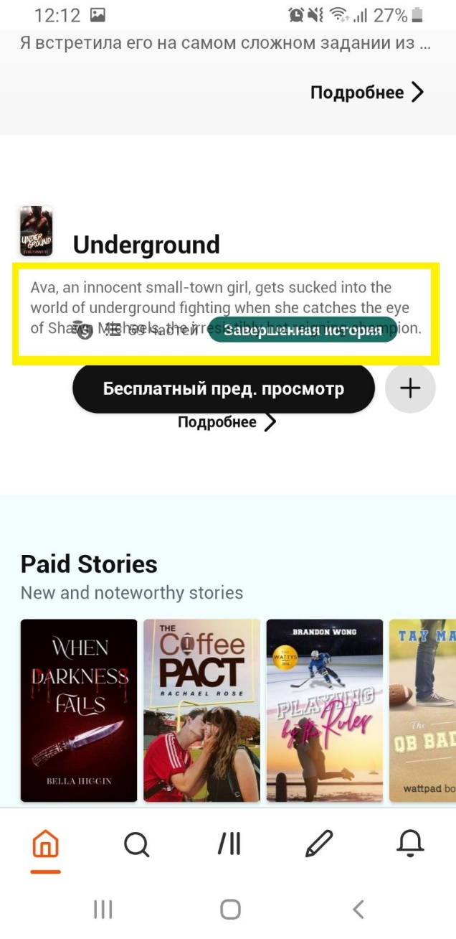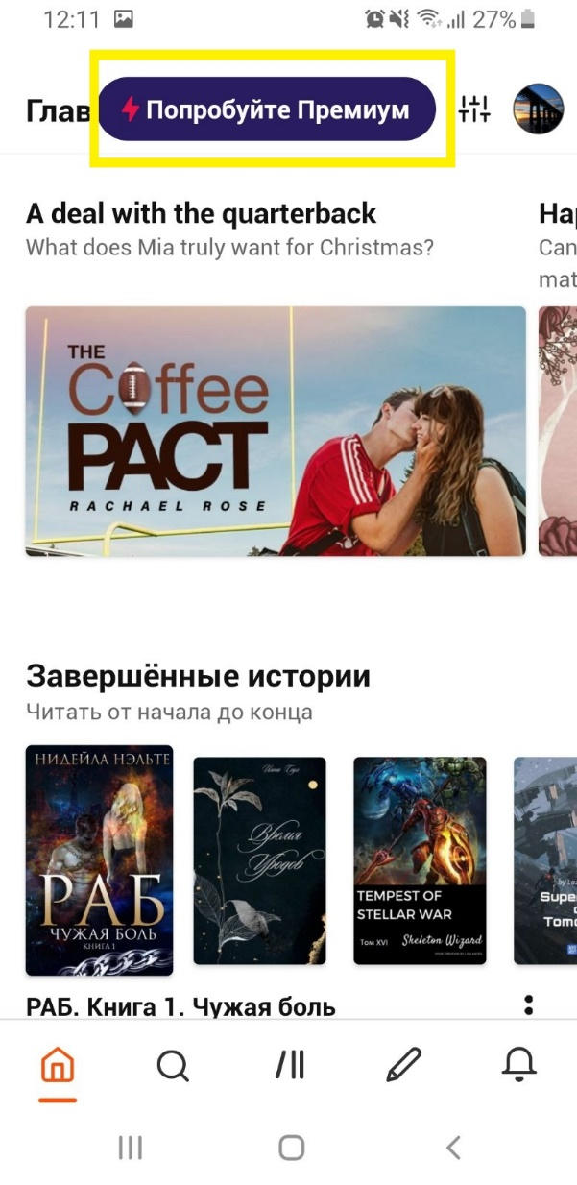

1. In the page of Политика конфеденциальности and Правила пользования the submenu icon shows inactive but clicking on it submenus are visible.

|  |  |
| --- | --- |
| **Bug ID:** | 2 |
| **Bug Summary** | In the page of Политика конфеденциальности and Правила пользования the submenus icon is inactive but clicking on it submenus are visible |
| **Environment/URL** | Wattpad Beta (Installed from Android market) |
| **Phone Model** | Samsung Galaxy S8 Plus |
| **Operation System:** | Android 9 |
| **Version** | Wattpad Beta 9.41.0.1 |
| **Submit Date** | 21/11/2021 |
| **Reporter** | Marine Hayrapetyan |
| **Steps to Reproduce** | 1.Open Application,  2.Enter to account,  3.Go to settings  4.Go to o Wattpad,  5.Go to Политика конфеденциальности or Правила пользования |
| **Expected Result** | Submenu icon should be visible as an active. |
| **Actual Result** | Submenu icon shows inactive. |
| **Screenshot/video** | Yes |
| **Notes** | - |
| **References** | - |
| **Severity** | medium |

